The First Portion of the Second Level Examination:

A Survey of Hidden Markov Models and Their Applications in Multimodal Data Fusion

Weihong Li

The Graduate Center
The City University of New York
Email: wli@gc.cuny.edu
http://www.cs.gc.cuny.edu/~liwh

October 2005
Contents
Abstract 2
1 Introduction 3
2 Hidden Markov Models 5
2.1 Markov Chain 5
2.2 Hidden Markov Models 6
2.2.1 Elements of HMMs 6
2.2.2 The Three Basic Problems for HMMs 9
2.3 Summary and Discussions 10
3 Extensions of Hidden Markov Models 12
3.1 Variable Duration HMMs 12
3.2 Factorial HMMs 13
3.3 Hierarchical HMMs 14
3.4 Coupled HMMs 16
3.5 Further Discussions 17
4 Unimodal and Multimodal Applications 18
4.1 Unimodal Data Processing 18
4.1.1 Audio: Speech Recognition 18
4.1.2 Video: Event Detection 20
4.1.3 Text: Information Retrieval 22
4.2 Multimodal Data Fusion 24
4.2.1 Bimodal Fusion: Audio-Visual Automatic Speech Recognition 24
4.2.2 Multimodal Data Fusion: Emotion Recognition 26
4.3 Summary and Discussions 27
5 Conclusions and Further Research Directions 29
Appendix 30
References 34

Abstract
Although hidden Markov models (HMMs) were initially introduced in the late 1960s and early 1970s, a large number of variations and enhancements have been proposed in the literatures recently. They have become increasingly popular in a variety of applications. There are two reasons why this has occurred. First, the mathematical structures of HMMs are very rich and therefore can be applied to a wide range of applications. Second, and most importantly, HMMs work very well for some important applications, such as, speech recognition, computational biology, handwriting recognition, and etc. Recently, hidden Markov models are found particularly useful in some new emerging areas in intelligent systems and pattern recognition, namely multimodal data fusion. In fact, HMMs have proven to be one of the most widely used statistical tools for sequential data processing. The objective of this survey paper is to summarize and compare variations and extensions of the HMMs, and to identify some research topics and applications, at the forefront of the exciting and challenging fields in man-machine intelligent systems.

1 Introduction
Human beings are good at recognizing patterns, such as faces, landmarks, etc. Based on these recognized patterns, people can make decisions in all kinds of different conditions. However, it turns out to be extremely hard for a computer to have the similar ability and therefore finish some tasks automatically. Pattern recognition is an active research field, with the goal to make a computer with the ability of recognizing all kinds of patterns, including objects, experiences, and knowledge, and/or to do decision-making for high level automatically tasks. Hidden Markov models, which were initially introduced in the late 1960s and early 1970s, are one of the most important and successful approaches in pattern recognition.
Hidden Markov models are probably the most widely used statistical models for sequential data pattern recognition, in which data change with times. Examples of such data include audio, video, seismic and other data sources. This kind of models has been very successful in some important applications, such as, speech recognition, gene finding in computational biology, handwriting recognition, and etc. The mathematical structures of the models are very rich and therefore can be applied to a wide range of applications. Some basic algorithms, which are used to estimate the parameters of HMMs for learning and for inferring, have been proposed in 1960s and 1970s [51-53]. Good tutorials on theory of HMMs and their applications to the speech recognition can be found in literature [2,3,37], also in [19], which focuses on applications to bioinformatics, and [38], which introduces a lot of variations and extensions of the HMM. Recently, HMMs have been applied to a variety of applications in addition to speech recognition [54], such as computational biology (bioinformatics) [27-29], event detection [30,31,32,43,44], emotion recognition [15,39,40,41], and audio-visual automatic speech recognition (ASR) [8,9.10,42]. Many of the applications have multimodal data that require a system to fuse data from these heterogeneous sources.
It is well-know that the joint probability distribution of a sequence of observations X₁^{T}={x₁, x₂, ... , x_{T},} can always be factored as
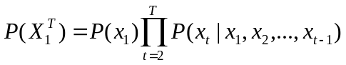
This would be intractable for a sequential data if the conditional probability P(x_{t} | x₁, x₂, ... , x_{t-1}) of an observed variable x_{t} depends on all the historical values (x₁, x₂, ... , x_{t-1}). The Markovian models, from which the HMM derived, can simplify this problem under a certain assumption. That is, past sequence can be summarized concisely, using a hidden random variable called a state variable, and therefore, the observed variable x_{t} at time t only depends on the previous state variable. Basically, the HMMs consist of two major tasks: inference and learning. The inference process is to discover the hidden states based on the observations. On the other hand, the learning processing is to estimate the parameters of the models based on the training data and therefore perform some prediction for the future or make a decision based on the test data.
The remainder of this survey is organized as follows. In Section 2, the statistical principles and the associated problems on HMMs are first introduced. The algorithms for solving the problems can be found in the Appendix, including the evaluation problem, the recognition problem and the learning problem. Section 3 presents the variations and enhancements for HMMs, including variable duration HMMs, coupled HMMs and factorial HMMs, etc. We will describe in Section 4 some applications to which the HMMs are successfully applied. We will start with those with unimodal data such as speech recognition, event detection and information retrieval, and then move on to those with multimodal data, such as audio-visual automatic speech recognition, and emotion recognition. Finally, Section 5 offers some conclusions regarding some further research issues on HMMs and their applications in multimodal data fusion.

2 Hidden Markov Models

2.1 Markov Chain
A sequence of random variables X_{n} is said to be a Markov chain if the following holds [1]:
(2.1)
The above equation implies that the current state X_{n} depends only on the previous state X_{n-1}, not on the whole history. This is called a first-order Markov chain. Likewise, if the current state depends on the previous k states, then the model is called a kth-order Markov chain. If this conditional probability does not depend on the index n, it is also called a homogeneous Markov chain.

Consider a system consisting of 3 states, S₁, S₂, and S₃, which at any time t, the system is in a state q_{t}. The system can transit from any state to any other state or itself with some probability. Please note, the output of the system at a particular time t corresponds to the state, which the system is in at this moment. This system is defined as a Markov model. A full probabilistic description of the Markov model, in general, require the transit probabilities, specification of the current state, as well as all the predecessor states.
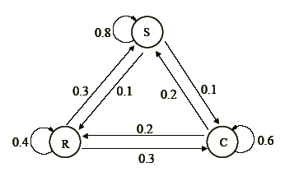
Figure 2.1: A simple three-state Markov model
Figure 2.1 shows a simple three-state weather example to illustrate the idea. Suppose the weather observed in a day has one of the following states:
State 1: Rain
State 2: Cloudy
State 3: Sunny
We can see here that each state has a corresponding physical meaning. Suppose the weather on day t is characterized by one of the above states, and the state transition matrix A, which is a probability matrix, is of the following value:
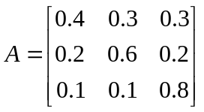
From the above transition matrix, we can easily find some properties:
Non-Negative: 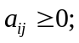
Sum-to-One: 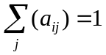, where j is the column index in A
These properties ensure that they obey standard stochastic constraints.

2.2 Hidden Markov Models
From the above discussion, we can see that the physical output for each state in a Markov model is determined. In other words, we know what is the output when we know which state the system is in. However, this model is too restricted in practice. For most of the applications of interest, a Markov model needs to be extended to a hidden Markov model (HMM), which is a doubly embedded stochastic process, to adapt more general practical problem. In the hidden Markov model, the output of the system is not determined by the state; instead, it can only be observed by another set of stochastic processes that produce the sequence of observation.

2.2.1 Elements of HMMs
To make the concept of the HMM clearer, let us first take a look at another example. Matrimonial contest problem, an excellent example provided in [4]. Here we provide a simplified version of the story. Once upon a time, the elder daughter of the emperor, beautiful Princess Variance, reached the age when maidens of the Empire get married. Then, the traditional matrimonial contest will be held in the Palace and the winner will marry the Princess.
When a princess is born, she is assigned a special servant by the Emperor. Every day from the day of the princess' birth to the day of her marriage, her servant has to visit four ponds in the Emperor's Garden, in accordance to a Markov process, and catch 100 fishes. The servant returns the fishes back to the ponds after recording their colors (red, blue, or green) and corresponding ponds. Each pond is strictly maintained and has its own proportion of fish of different colors. Every day, the Emperor's mass media announces the results of the fishing.
The contest procedure is interesting: 10 days before the contest, the servant starts to put every caught fish (still 100 fishes per day) into a transparent numbered jar and sends it to the Palace until the day the contest begins. (Suppose that taking out 1000 fishes does not change the statistical properties of the ponds). On the day of contest, the one who can guess as accurately as possible from which pond each fish came will win the Princess' hand in marriage.
As a matter of fact, the above problem can be well modeled by an HMM. Before that, let us formally define the elements of a hidden Markov model and understand how the model generates observation sequence. An HMM for discrete symbol observations is characterized by the following [3]:
1) N, the number of states in the model. For many practical applications, there is often some physical significance attached to the states or to sets of states of the model, though the states are hidden. Generally speaking, the states are interconnected in such a way that any state can be reached from any other state, which can be interpreted by a directed graph; The individual states are denoted as a set S={S₁, S₂, S₃, ... , S_{N}}, and the state at time t is denoted as q_{t}. In the above matrimonial contest problem, the four ponds correspond to the hidden states and of course, the number N is equal to 4.
2) M, the number of distinct observation symbols per state, namely, the discrete alphabet size. The observation symbols, which correspond to the physical outputs of the system being modeled, belong to the set M. The symbols are denoted as a set V = {v₁, v₂, ... , v_{M}}. For the matrimonial contest problem, the observation symbols correspond to the colors, namely "red", "green" and "blue", and the number of the distinct observation symbols M is equal to 3.
3) The state-transition probability distribution A = {a_{ij}} where
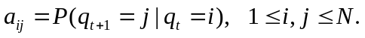 (2.2)
For the special case in which any state can reach any other state in a single step, we have a_{ij} > 0 for all i,j. For other types of HMMs, we would have a_{ij} = 0 for one or more (i,j) pairs, meaning that there is no transition from state i to state j.
4) The observation symbol probability distribution, B = {b_{j}(k)}, in which
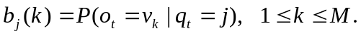 (2.3)
namely, the probability of observing symbol v_{k} at the state j. This defines the symbol distribution in state j, j = 1, 2, ... , N. In terms of the matrimonial contest problem, this probability defines the proportion of fish of different colors for each pond.
5) The initial state distribution π = { π_{i} } in which
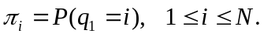 (2.4)
Given the values for the above defined elements: N, M, A, B, and π, the HMM can be used as a generator to give an the observation symbol sequence
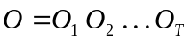
where each observation symbol O_{t}, t=1, 2,..., T, is generated by a state v_{t} from the state set V, and T is the number of the observation symbols in the sequence. The process of generating the observation sequence is the following:
1) According to the initial state distribution π, choose an initial state q₁=S_{i}
2) Set t = 1
3) According to the symbol probability distribution in state S_{i}, i.e., b_{i}(k), choose O_{t}=v_{k}
4) According to the state transition probability distribution for state S_{i}, i.e., a_{ij}, transit to a new state q_{t+1}=S_{j}.
5) Set t = t+1; return to step 3) if t<T; otherwise terminate the procedure.
The above procedure can be used as both a generator of observation symbols, and as a model for how a given observation symbol sequence was generated by an appropriate HMM.

From the above discussion, it can be seen that a complete specification of an HMM requires the specification of the two model parameters, N and M, the specification of observation symbols, and the specification of the three probability measures, A, B and π. Basically, we can specify an HMM using the following compact notation
λ= (π, A, B) (2.5)
to indicate the complete parameter set of the model.

2.2.2 The Three Basic Problems for HMMs
Given the above definition of HMMs, there are three related problems to be solved in order to make them useful for real world applications. They are the evaluation problem, the decoding or recognition problem, and the learning problem [3,4].
• Problem 1 (The Evaluation Problem)
Given the observation sequence O = O₁O₂…O_{T}, and a model λ, how do we efficiently compute P(O|λ) , namely the probability of the observation sequence, given the model λ= (π, A, B).
• Problem 2 (The Decoding or Recognition Problem)
Given the observation sequence O = O₁O₂…O_{T}, and the model λ, how do we choose a corresponding state sequence Q = q₁q₂…q_{T} , which is optimal in some meaningful sense.
• Problem 3 (The Learning Problem)
How do we adjust the model parameters λ= (π, A, B) to maximize P(O|λ).
Now, let us re-visit the matrimonial contest problem. As we have seen, this contest problem can be well modeled by a hidden Markov model. It is nature to model the four ponds as the hidden states. And the colors of the fish, namely "red", "green", and "blue", are naturally considered as the observation symbols. Then, our data is a sequence of observations O of length L=1000. Every data element is obtained from one of four ponds, or we can say "a data point was emitted in some state q". A first-order Markov chain can be defined by the following formulas:
π=(π₁, π₂, π₃, π₄)
A={a_{ij}}, 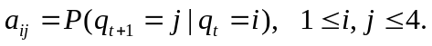
B={b_{j}(k)},
Since the sequence of state that produces the observable data is not available, i.e., is hidden, the above model is called a hidden Markov model. An HMM can also be considered as a double stochastic process or partially observed stochastic process. Figure 2.2 shows an example of this model with the parameters. The goal for the contest problem is to recover the sequence of the hidden states which produce the observations (the colors of the caught fish) as accurately as possible. In order to achieve the goal, we need to know some general solutions for our three basic problems, which are provided in the Appendix as a reference.
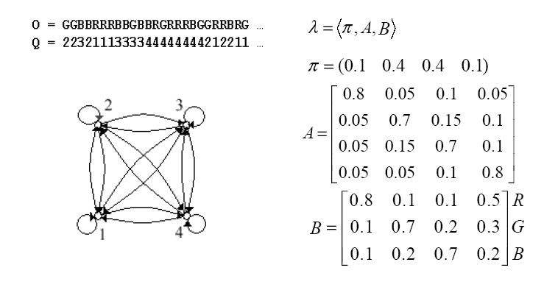Figure 2.2: Four-pond HMM and the parameters

2.3 Summary and Discussions
We have discussed Markov chain and hidden Markov models in this section. And examples were presented to illustrate intuitive ideas for both Markov chains and HMMs. The algorithms for solving the basic problems associated with HMMs proposed by Baum, et al [51-53] are presented in the Appendix as a reference.
Now, let us take a look at the computational complexity for the algorithms of the standard HMMs. From the appendix equation (A.2) and (A.4), we can see that the computational complexity for evaluation problem is O(N²T). Note that N is the number of states, and T is the length of observations. Therefore, it is almost a linear algorithm for the evaluation problem given there are not so many states in the model. And it should also be noted that the efficient Viterbi algorithm for decoding or recognition problem is similar to the forward-backward algorithm used in evaluation problem, therefore, the computational cost is also close to a linear.
The learning or parameter estimation problem is the most complicated problems associated with a HMM. The most widely used expectation-maximization (EM) algorithm for learning is an iterative algorithm successively applying the E-Step and M-Step. Because EM algorithm is using maximum likelihood (ML) criterion, this algorithm tends to stop at a local maximum without any particular treatment for the starting value of the parameters. Although it is possible to obtain an analytic solution for M-step using gradient techniques, the whole learning process is still computationally expensive.

Another problem of using HMM is over-fit, namely trained model can fit the training data set very well but doesn't perform well on test set. This problem is usually caused by too many parameters of the model or shortage of the training data. The time complexity issue and the over-fitting issue need to be seriously considered for applications, particularly for the more complicated multimodal data fusion problems.

3 Extensions of Hidden Markov Models
Although standard HMMs are double stochastic processes and therefore are much powerful than the Markov chain for modeling real applications, there are still some weaknesses on them. For example, it is extremely hard for a standard HMM to model the state duration, which exists in some applications, such as physical signals and gene finding problems. Also, the standard HMMs almost have no way to handle multi-level stochastic processes, like context in speech recognition. It is also useful to enhance the basic HMMs to enable distributed state representation. In this section, we will exam some extensions of HMMs, which are aimed to solve the above modeling problems in real problems that will be discussed in Section 4.

3.1 Variable Duration HMMs
One of the major weaknesses of the standard HMMs is the modeling of state duration. For most physical signals, it would prefer to explicitly model duration density in some analytic form [3]. According to the standard HMM, if we want to compute the probability of observing d consecutive observations in state S_{i}, with self transition coefficient a_{ii}, the result is:
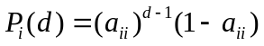 (2.6)
This computation can be easily computed via state duration probability P_{i}(d) in the variable duration HMM shown in Figure 3.1(b). Figure 3.1 shows both standard HMM and a variable duration HMM. The differences between HMMs without and with explicit duration state are: (1) the self transition are set to zero and hence are removed from the architecture in variable duration HMMs; and (2) an explicit duration density is specified.
As a matter of fact, the variable duration HMM can be converted to a standard HMM through the equation (2.6). The advantage of incorporating state duration densities is that the quality of the modeling is significantly improved. Therefore, the modeling for some applications becomes more intuitive and effective. The drawback is that largely increased computation load associated with this enhanced HMMs, mainly introduced by the training processing to obtain the explicit duration density. A good application of this variable duration HMM can be found in the gene finding problem in [27].

a_{ij}
a_{ji}
S_{i}
S_{j}
a_{ii}
a_{jj}
a_{ij}
a_{ji}
P_{i}(d)
P_{j}(d)
S_{i}
S_{j}
(a)
(b)

Figure 3.1: (a) a standard HMM and (b) a variable duration HMM

3.2 Factorial HMMs
A standard HMM, which assumes a multinomial state distribution, severely limits the representational capacity of HMMs. For example, to represent 16 bits of information about the history of a time sequence, an HMM would need 2¹⁶ distinct hidden states, which is almost useless model because of its complexity. Ghahramani and Jordan [33] proposed a distributed state representation, called factorial HMM, which could achieve the same task using only 16 binary state variables.
Figure 3.2 (a) shows a standard HMM. As mentioned in Section 2, a standard HMM is modeled by two independent random variables: the state S_{t} is a single multinomial random variable that can take one of K discrete values and the observations Y_{t} is another single multinomial random variable that can take one of D discrete symbols. The state transition probabilities are specified by a K×K transition matrix and the observation probabilities can be specified by a K×D observation matrix. The factorial HMM, showed in Figure 3.2 (b), is a generalization of the standard HMM. The factorial HMM generalize the state represented by a collection of state variables S_{t} = S_{t}⁽¹⁾, ... , S_{t}^{(m)}, ... ,S_{t}^{(M)}, and each of variable can take on K^{(m)} values. Note that the state transition is constrained: each state variable evolves according to its own dynamics. Namely, there are no transition between two states which are belongs to different state variables. Therefore, the state transition probabilities are specified by M distinct K×K transition matrix. As depicted in figure 3.2 (b), the observation Y_{t} of a factorial HMM at time step t can depend on all the state variables at that time step.
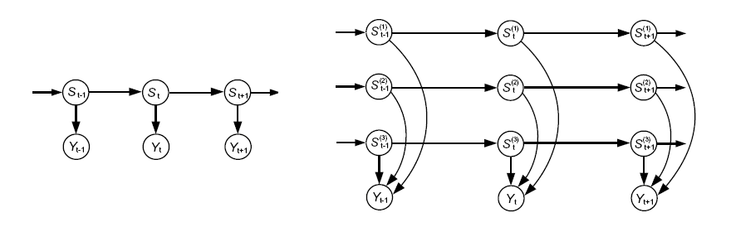
Figure 3.2: (a) A standard HMM (b) a factorial HMM (Ghahramani and Jordan [33])
The inference and learning algorithm for factorial HMM could be similar to those of standard HMMs. Due to the combinatorial nature of the hidden state representation, the exact algorithms are intractable because of the exponential computation complexity. The general solution for these kinds of intractable problem is to carry out approximate computation using Gibbs sampling or some other methods [33].

3.3 Hierarchical HMMs
Another weakness of the standard HMMs is unable to handle the natural multi-level stochastic processes, like context in speech recognition. Fine, et. al. [5] proposed the Hierarchical hidden Markov model (HHMM) to attack this problem. The HHMM is motivated by the multi-scale structure that appears in many natural sequences, particularly in language, handwriting and speech. The advantage of this model is able to model the different stochastic levels and length scales and is capable of inferring correlated observations over long periods in the observation sequence via the higher levels of the hierarchy.
HHMM generalize the standard HMM by making each of the hidden states an HHMM or an HMM as well. Therefore, the output of a hidden state is not just a single observation symbol, but an observation sequence. An HHMM generates sequences by a recursive activation of one of the substates of a state. And this substate may also contain substates and therefore activate one of its substates. This process of recursive activations ends when a leaf state or production state is reached. These production states are the only states that emit output symbols and those states that do not emit observable symbols directly are called internal states. After the completion of a vertical transition, the transition is back to the same level, that is, the horizontal transition.
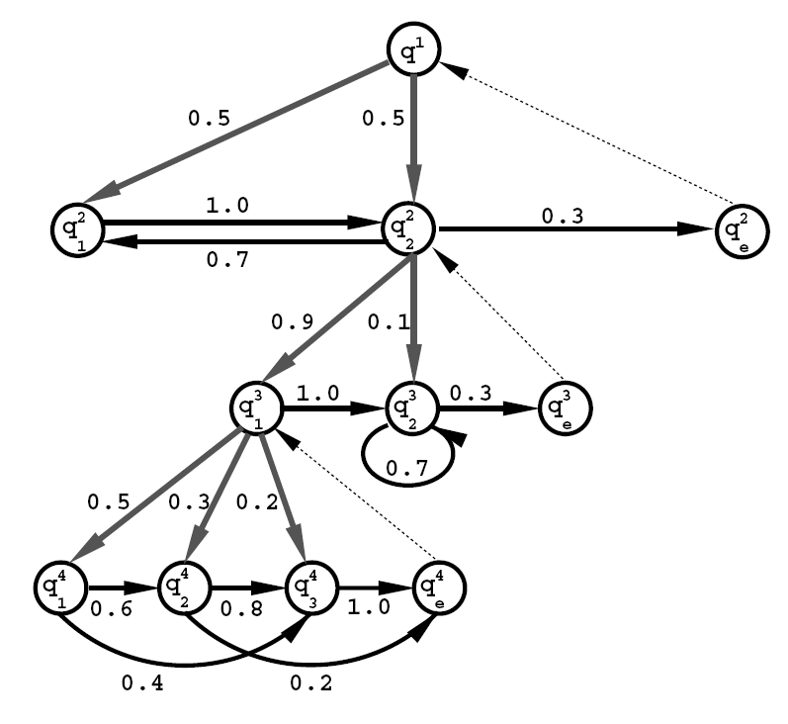
Figure 3.3: The architecture of an HHMM of four levels (Fine et al [5])
From the above description, it is easy for us to know that the HHMM is constructed and modeled in the way of the depth-first tree. Figure 3.3 shows an example of the HHMM. Gray and black edges denote the vertical and horizontal transition respectively with corresponding probability associated with the edges. And the dashed thin edges denote returns from the end of each level to the parent of the level, which initializes the state transition. Eventually, the transition stops at the root state.
A similar technique as standard Baum-Welch is used to estimate the parameters for the HHMM. The HHMM is applied to the multi-level structure for English text and unsupervised learning of cursive handwriting [5,38].

3.4 Coupled HMMs
To fuse multiple channels media data, Brand [6] at MIT Media Lab proposed coupled hidden Markov model (CHMM). CHMMs are found useful in many circumstances when multiple channels of data or multimodal data need to be fused [7-10]. Figure 3.4 illustrates a two-chain CHHM with T length observations.
first
channel
second
channel
t = 1
t = 2
t = 3
t = 4
t = T

Figure 3.4: The architecture of a coupled hidden Markov model
There are two state variables in the figure, which are depicted by the two rows of circles. The state of the system at certain time slice t is jointly determined by the states of these two multinomial variables. Additionally, the state of each state variable is dependent on both of its two parents in the previous time slice.
In addition to the two state variables, two observation variables are modeled using separated channels. Each observation variable is a private child of one of the state variables. The observation variables could be either discrete or continuous and it is also possible that one of the observation variables is continuous and the other one is discrete.

One of the advantages of the coupled HMM is that it enables asynchronous progression of the two state variables. This is particularly useful in applications of multimodal data fusion, such as audio-visual ASR, emotion recognition and etc.

3.5 Further Discussions
We discussed several extensions of HMMs in this section. These extension have enhanced a standard HMM in a variety of aspects: instead of using the self transition, variable duration HMMs enable explicitly state duration density, which significantly enhance the modeling for some applications, like gene finding problem and some other physical signal process problem, which duration time staying in states is largely different. Factorial HMMs are designed for distributed states modeling. They are able to easily handle some complicated representational problems in a distributed way, which are almost impossible by using any standard HMM. Multiple levels pattern recognition problems, such as speech context understand, can be solved using hierarchical HMMs, which are capable of inferring correlated observations over long periods in the observation sequence via the higher levels of the hierarchy. And coupled HMMs are good choices for solving multimodal data fusion problems, since the architectures of coupled HMMs support multi-channel data interaction and therefore a natural ability to handle data from multiple modalities.
The downside of these extensions of course is the increased computation complexity. For variable duration HMMs, the extra learning is required for obtain the explicit duration density P_{i}(d) [3,27]. Due to the combinatorial nature of the hidden state representation, the exact inference and learning algorithms for factorial HMMs are intractable. Therefore, some approximate methods, like Gibbs sampling, have to be carried out for inference and learning [33]. The generalized Viterbi algorithm and Baum-Welch algorithm for hierarchical HMMs is O(NT³). Although Fine, et al [5] claimed that they devised a heuristic method to find an approximation, the computational complexity is still high, namely O(NT²). Also, the cost for generalized inference and learning algorithms for coupled HMMs is O(TN^{2C}), where C is the number of chains. Fortunately, Brand [6] can be improved this to O(T(CN)²) using approximation methods.

4 Unimodal and Multimodal Applications
Hidden Markov models are widely applied to speech recognition problems. We can find a huge number of papers describing it on speech recognition. Good tutorials on theory of HMMs and their applications can be found in [2,3,37,38]. There are also some new varieties on HMMs [47-50] based on speech recognition. In this survey paper, we will look at their applications with various modalities rather than just a single modality. We will start with a bank of unimodal data processing, such as audio, video and text, and observe the similarities and differences in using HMMs. Then we will focus our attention on applications that take advantages of multimodal data sources, such as audio-visual automatic speech recognition, emotion detection, etc., for better pattern recognition using HMMs. Finally we will give a summary and comparison.

4.1 Unimodal Data Processing
The unimodal data mentioned here refers to a homogenous data collected by a single sensor, such as audio, video, image, text, seismic, and etc. Studying challenging issues and shortcomings of HMMs using unimodal data will help us understand the importance of using multimodal data, where data obtained from multiple sensors are intended to be fused together for better pattern recognition results. Needless to say research results on unimodal data are fundamental to the researches of multimodal data fusion. We will use the following applications as examples of unimodal data processing: speech recognition, event detection, and information retrieval.

4.1.1 Audio: Speech Recognition
Because speech recognition has been the most common applications of HMMs, we will first discuss it here. The basic speech recognition problem can be stated as follows: given a sequence of speech signal, by extracting the corresponding sequence of acoustic descriptors or features, find out the sequence of words intended by the speaker who pronounced those words.
Many speech recognition techniques have been proposed. In the early days, the methods used to attack this problem are mainly focus on filter-bank analysis, linear predictive coding (LPC) analysis, time alignment and normalization, clustering algorithms and etc. In the 1980s, HMMs have been the main research tools for large vocabulary continuous speech recognition [3,4]. And now, the stochastic process and interaction strategy are used to obtain the syntax and semantics from the speech and targeted to multimodal dialog problem [57, 58].
Let us first consider isolated speech recognition, which is simpler than connected speech recognition. For isolated word recognition, a single HMM can be built for each word w within a predefined vocabulary. Given an acoustic sequence X₁^{T}={x₁, x₂, ... , x_{T},}, one can compute P(X₁^{T} | w) for each word w within the vocabulary. When an a priori distribution P(w) on the words is also given, the most likely word w* given the acoustic sequence can be obtained by picking the model which maximizes both the acoustic probability and the prior:
The computational cost for recognition is simply the number of words times the computation of the acoustic probability for a word.
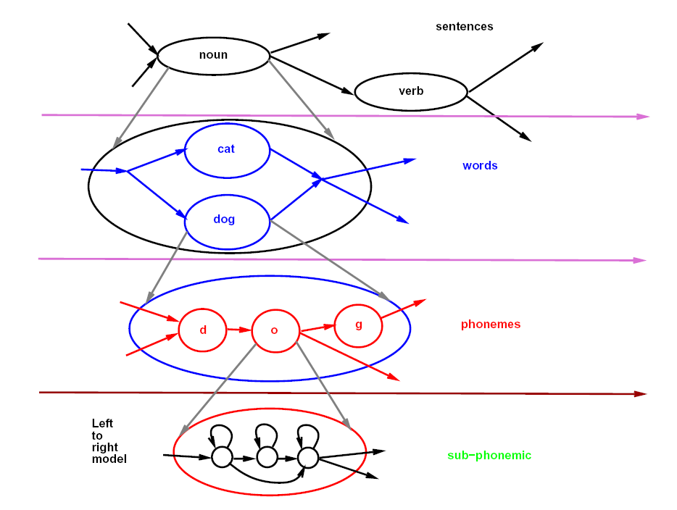
Figure 4.1: Example of hierarchical HMM for speech recognition (Bengio [38])
A more complicated and general task is to recognize connected speech, which is called connected speech recognition. In this case, we can generalize the isolated speech recognition system by mapping from an acoustic sequence to a sequence of words:
where 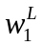 represents the word sequence with length L. It is clearly that directly enumerate the above word sequencesis NP-Hard. Fortunately, the language model 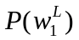, which characterizes the structural dependencies in sequences of symbols, largely constrains the available word sequences. In other words, most word sequences are very unlikely in a particular language, and in a particular semantic context. Figure 4.1 shows an example of the above model with hierarchical HMM for speech recognition. Today, audio-visual speech recognition has been investigated by many research groups [8,9,14] in hoping that adding lip reading will improve the recognition rate of a speech recognition system. We will discuss this topic in the second part.

4.1.2 Video: Event Detection
Recognizing activities or events taking place in a video stream is a major task in many applications, such as video surveillance system, video indexing, video annotation and video summarization [43-46]. In video surveillance, rare events detection received particular attention for security purpose. Since video sequences are also sequential, HMMs have been used in the activity detection and rare event detection [30-32].
Chan et al. [30] introduced a semantic primitives combined with HMM for rare events detection in aerial video sequence, which has little or no training data. Figure 4.2 shows an instance of loading/unloading activities in airport area, which are monitored by aerial video. The relevant concepts include an object to be transported, an instrument of conveyance, a source and a destination location. In figure 4.2 (a), we can see that the forklift is unloading the cargo container from the airplane (source) to the truck (destination).
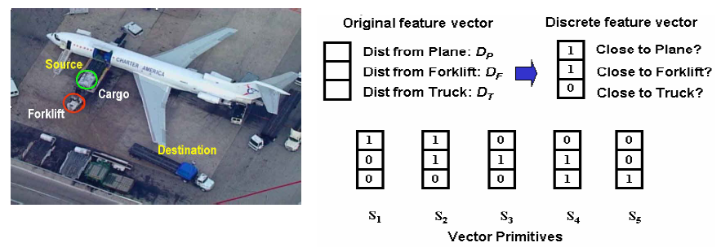
Figure 4.2: (a) An event in aerial video (b) A mapping for getting semantic primitives (Chan et al. [30])
To obtain the semantic primitives, the continuous event is mapped to discrete feature vector based on the distances from objects to the cargo. For example, three distances are defined to generate the feature vector: distance from airplane to the cargo, D_{P}; distance from forklift to the cargo, D_{F}; and distance from truck to the cargo, D_{T}. The feature vector is binarized by thresholds to the discrete feature vector consists of three elements: close to plane, forklift or truck (1) or not (0). Based on the above definition, five vector primitives, S₁ through S₅, are naturally generated for loading/unloading activities as shown in figure 4.2 (b). They are approaching (100), unloading (110), transport (010), loading (011) and departing (001). Figure 4.3 shows an HMM composed of these 5 states that model a complete unload and load cycle.
Apparently, adding audio, or even other modalities such as seismic, magnetic signatures of the subjects will be able to improve the robustness and/or accuracy of a video event detection system. Multimodal data fusion for event detection using HMMs will be interested research topic.
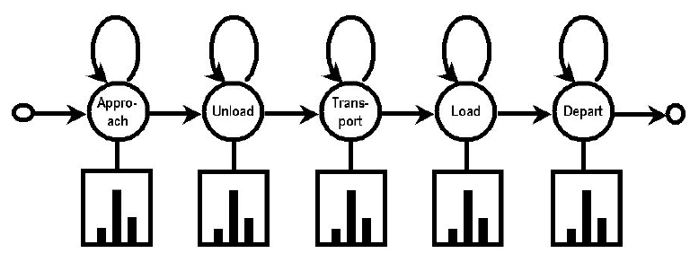
Figure 4.3 A complete load/unload cycle HMM architecture (Chan et al. [30])

4.1.3 Text: Information Retrieval
HMMs are also used to some information retrieval system. Miller, et al. [55] demonstrates that the HMM-based method outperforms the standard information retrieval method, tf.idf, on both the TREC-6 and TREC-7 ad hoc retrieval tasks. The information retrieval problem can be model as the following probability model:
Given a user-generated query Q and a set of documents D, we wish to rank the documents based on the probability that D is relevant, conditioned on the fact that the user produced Q, i.e., P(D is Relevant|Q).
According to Bayes' rule, the above probability can be decomposed into the quantities that are easily estimated:
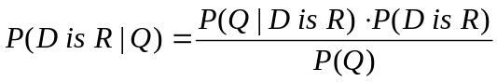
where P(Q|D is R) is the probability of the query being posed, under the hypothesis that the document is relevant; P(D is R) is the prior probability that document D is relevant; and P(Q) is the prior probability of query Q being posed. Since P(Q) is identical for all documents D, this term can be safely discarded while evaluating the whole equation.
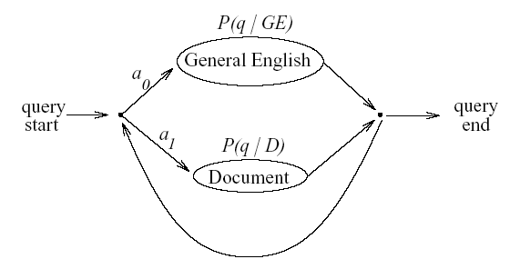
Figure 4.4 A simple two-state HMM for information retrieval (Miller, et al. [55])
Miller et al. proposed a simple two-state HMM architecture shown in Figure 4.4. The first state, which is labeled as "Document", represents choosing a word directly from the document. The second one, labeled as "General English", represents choosing a word that is unrelated to the document, but that occurs commonly in natural language queries. Also there are two null states, which produce no output, in the model. This corresponds to an assumption that the choice of current word to be generated is independent of the previous choice. Therefore, there are only two transition probabilities needed, a₀ and a₁, instead of the possible four. Please note that each document in the database or corpus has a representation of this HMM.

Miller et al use a simplified parameters estimation strategy instead of the conventional EM algorithm. First, the output distribution for the "Document" state, P(q|D), is set to be the sample distribution on words appearing in that document. That is, for document D_{k},
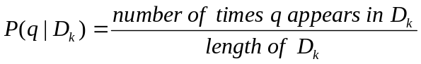
For state labeled as "General English", the sample distribution of the entire document corpus is used,
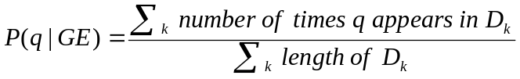
With the above parameters estimated, the probability of the query being posed under the hypothesis that the document is relevant can be estimated by
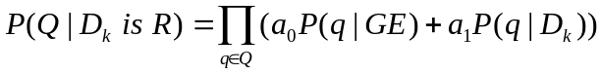
This equation is used to compute P(D_{k} is R|Q), which is the value used to rank documents eventually.
Text is still the main media for information retrieval and data mining. Nevertheless, multimedia information retrieval and multimedia data mining have attracted increased attention [20-22]. Content-based image and video analysis and retrieval algorithms have been the mainstream for multimedia data processing. Rui et al [17] reviewed the content-based image retrieval problem and approaches and Aigrain et al [18] did the similar review mainly focused on video retrieval problem and approaches.
The above discussed approaches are mainly based on color, shape, texture, or spatial similarity measurement for image retrieval and key-frame analysis for video retrieval. Using HMMs to study data mining with text, video and audio will be another interesting research topic. Ghoshal et al [23] did some preliminary research on this problem, and the results are promising. Much more can be done to improve their approaches, including context-dependent modeling, unsupervised adaptation, adaptive and discriminative training, and minimum error decoding.

4.2 Multimodal Data Fusion
From the above applications, it is obvious that usually multimodal data sources are available for many tasks, such as speech recognition, event detection, and information retrieval. The advantage of algorithms based on multiple modalities is that they at least offer an alternative choice when a single modality is not available or too noisy in some circumstances. And more importantly, algorithms based on multimodal data usually outperform any single modality based methods in the applications [8,9,13,39]. Algorithms for multimodal data fusion based on HMMs are actively studied and HMMs have proven to be useful tools for data fusion.

4.2.1 Bimodal Fusion: Audio-Visual Automatic Speech Recognition
Applications of automatic speech recognition (ASR) systems have driven a large number of developments in HMMs over last decades. Recently, the audio-visual based ASR has received more attention. This research is motivated by the work of McGurk and MacDonald [13] who showed that human beings are able to better distinguish spoken sounds when both audio and video are available. A typical audio-visual ASR system makes use of two modalities, namely audio and visual, to improve the performance of ASR systems.
There are two problems needs to be solved in order to implement an audio-visual ASR system. First, a real time algorithm is needed to extract the lip information, namely to obtain visual features in real time. Second, we need an algorithm or a model to integrate the audio and visual information.
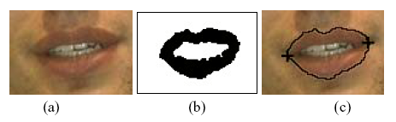
Figure 4.7: (a) the initial mouth area (b) segmented lip region using LDA (c) lip contour and mouth corners (Nefian, et al. [9])
To solve the first problem, i.e., obtaining the visual features, we can starts with the detection of the speaker's face in the video sequence [14]. Then, the lower half of the detected face is a natural choice for the initial estimate of the mouth region. Next, the mouth region is segmented out via some computer vision techniques, e.g., linear discriminant analysis (LDA) and the lip contour and position of the mouth corners are detected as shown in Figure 4.7. Researchers use different visual features as the observation vector to integrate with audio features. The primary visual features include: the vertical opening of the upper and lower lips, and the distance between the two mouth corners. Chu and Huang [8] also used Delta features, thus the actual visual feature vector is six-dimensional. On the other hand, Nefian, et al. [9] use 15 coefficients, which corresponding to the most significant generalized eigenvalues of the LDA decomposition, as visual observation vector.
Because of its inherent bimodal characteristic, coupled hidden Markov model (CHMM) is a widely chosen model for integrating the audio and visual modalities. We know that the audio and visual modalities are not necessarily synchronous, and actually most of time they are asynchronous. Modeling the integration using CHMM takes into account the above fact and hence proves to be an efficient technique by many researchers [8 –10].
The inference of the coupled HMM uses a generalized Viterbi algorithm. The recursive step of the generalized Viterbi algorithm is as follow. Please note, all other formulas are ignored since they are the same as the basic algorithms.
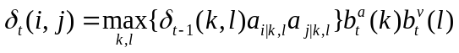
where state i, k and j, l are audio and video state random variables respectively. a_{i|k,l} is the transition probability of given audio state in k and video state in l at time t-1, the audio state transits from state k into state i at time t. And a_{j|k,l} is the transition probability of given audio state in k and video state in l at time t-1, the video state transits from state l to state j at time t. And b_{t}^{c} = P(O_{t}^{c}|q_{t}^{c}=i), c = a or v, namely the cth channel (audio a or video v) observation probability of emitting output symbol O in state i at time t. From the above formula, the optimal current state is obtained by retrieving the maximum value of the multiplication of the audio (a), video (v) transition probabilities and the corresponding state probability at time t-1.
To estimate the parameters of the CHMM, Chu and Huang [8] tried to transform the CHMM into a standard HMM by combining the audio and video states and grouping the observations. After this, the standard EM training algorithm can be readily applied to the transformed model.

4.2.2 Multimodal Data Fusion: Emotion Recognition
Emotion recognition is one of the latest research topics in intelligent human-computer interaction and it is becoming more and more important in the intelligent communication between human and computer. Facial expression based emotion recognition research has been studied since 1970s. Most of previous work is focused on extracting emotions from visual or audio information separately [15,40,41]. Recently, emotion recognition based on the integration of multi-modalities has received much more attention [9,39,42].
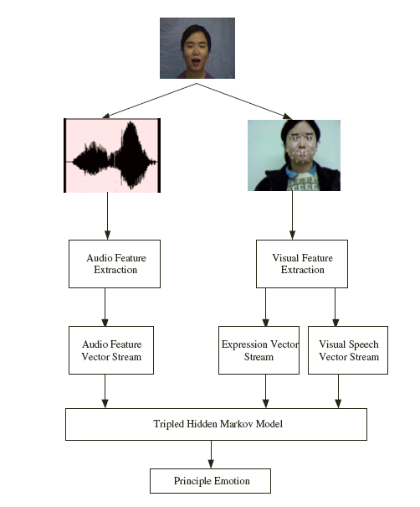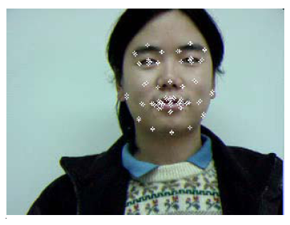
Figure 4.8 (a) the general architecture for emotion recognition.(b) the facial features (Song, et al. [39])
Song, et al. [39] proposed a tripled HMM for emotion recognition, in which the audio-visual features together with facial expression are integrated together to better infer the emotion of the human. Figure 4.8 shows the general architecture of the proposed approach. The audio information is extracted as the acoustic features by the method proposed in [15]. The feature parameters include the energy features and pitch features. In order to characterize instantaneous pitch, a simple auto-correlation analysis is performed at every frame. The visual information consists of visual speech features and expression features extraction. The MPEG-4 standard extends facial action coding system (FACS), to derive facial definition parameters (FDP) and facial animation parameters (FAP). FAP has been widely used in facial animation for its good compression. Fifty-four parameters out of sixty-six FAP were chosen by Song, et al. to represent the expression because some parameters are not associated to expression. Active appearance model (AAM) [16] is used to track the facial feature points in temporal-spatial domain because of its robustness and real time. Figure 4.8 (b) shows an example of the facial feature points tracking.
The tripled HMM，which is used to integrate the audio, visual and facial expression features, is similar to the coupled HMM used for audio-visual ASR system. The recursive step, which is the key step of the model, is written as
where the variables are of the same meaning as those mentioned in the audio-visual ASR system.

4.3 Summary and Discussions
In addition to the applications presented above, there are also some other applications, to which the HMMs are applied successfully [54], such as econometrics, climatology, communications, handwriting and text recognition, etc. With the goal of looking at HMMs for multimodal data fusion applications for human-machine interaction, we mainly focus on interesting applications that use various sensing modalities for pattern recognition tasks. Basically, the applications are divided into two categories: those applications, which only deal with data from single modalities, such as audio, video, text, etc., are grouped into unimodal data process. However we have noted that many of those applications could have multimodal data available that may improve the performance of the corresponding pattern recognition systems. Another categorydeals with multimodal data fusion. We mainly focus on the integration of audio and video data in computer vision.

There are no general solutions for all research problems. To solve a particular task, one has to choose appropriate HMMs or the extensions and model the task based on the domain knowledge. Some extensions are much powerful compared with the original model, but the computation complexity for the parameter estimation is high. Therefore, some approximation methods, such as Gibbs sampling, need to be incorporated into the training processing to reduce the computational complexity.
Although many research communities have been benefit from the use of the HMM technology, there are some inherent limitation in the technology itself. A major limitation is the assumption that successive observations are independent, and hence the probability of a sequence of observations P(O₁, O₂, ... , O_{T}) can be simplified as a product of the probabilities of individual observation, that is,
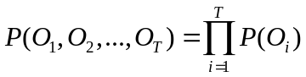
This is not necessary the true for most of the real applications. Another limitation is the assumption that the distributions of individual observation parameters can be well represented as a mixture of Gaussian densities. And this is also a strong restriction for most of the applications. Finally, the Markov assumption itself, that is, the probability of being in a given state at time t only depends on the state at time t-1, is not suitable for real applications where dependencies often extend through several or even more states.
However, in spite of these limitations, HMMs has worked extremely well for certain types of applications. And though the above assumptions are not always met by the applications, the approximation tools using the HMMs also work well. Understanding these limitations and therefore trying to enhance the model is still definitely a research direction. Also, it is important for researchers and engineers to think carefully on the above assumptions before applying this statistical model to a particular application.

5 Conclusions and Further Research Directions
Hidden Markov models are the most widely used statistical tools for sequential data processing. A lot of variations and enhancements have been proposed since it was initially introduced in the late 1960s and early 1970s. This survey shows that HMMs have been applied to many other applications after it was successfully applied to speech recognition system. These applications include various unimodal data processing and various multimodal data fusion applications. For example, event detection, information retrieval in unimodal data processing and emotion recognition, audio-visual ASR in multimodal data fusion.
Multimodal data fusion is an emerging research topic in computer vision and is receiving increasingly attentions recently. HMMs and their extensions are very useful tools for multimodal data fusion problem. Some future research directions include:
- New architecture and enhancement of HMMs for integrating multiple modalities. These new extensions would show their improved representation ability for new applications, such as possible integration of data from vision, sound, touch, thermal and perhaps taste and smell.
- More efficient inference and learning algorithms are required for some complicated extensions of HMMs in order to obtain the real time performance.
- Theoretical studies on efficiently determining the hidden states and corresponding HMMs based on observations and domain knowledge.
- Methods to extract effective features from the modalities in order to better fitting multimodal data into the architecture of HMMs.
- The effectiveness of a multimodal data fusion depends largely on the performance of each modality taken separately. Therefore, more efforts could be produced to improve some modalities where remarkable progress is still possible to be accomplished, like data from vision, taste, smell, etc.

Appendix
1 The Evaluation Problem: Forward-Backward Algorithm

To solve the evaluation problem, that is, efficiently evaluating the probability of observing a sequence of observations for a given model, the forward-backward procedure is proposed to reduce the computational complexity [4]. The forward-backward procedure is based on the dynamic programming technique, which makes use of the previous computed value for further calculations. The key point of this technique is to find a recursive property that allows us to do calculations for the next instance based on the current one.
The forward algorithm can be described as follows. Let the forward variable α_{t}(i) be defined as
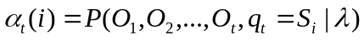 i = 1, 2, ..., N (A.1)
That is, the probability of observing the partial observation sequence, O₁, O₂, . . . ,O_{t}, and in state S_{i} at time t, given the model λ. We can solve for α_{t}(i) inductively:
Initialization: 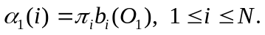
Recursion: 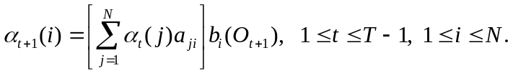 (A.2)
Termination: 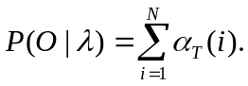
Likewise, we can introduce a symmetrical backward variable β_{t}(i) as the conditional probability of the partial observation sequence from O_{t+1} to the end to be produced by all state sequences that start at ith state:
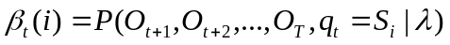 (A.3)
The backward procedure calculates recursively backward variable going backward along the observation sequence as the following formulas:
Initialization: 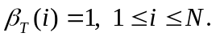
Recursion: 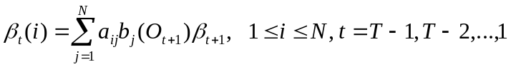 (A.4)
Termination: 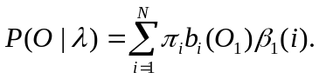
β_{t+1}
1
2
N
1
2
N
a₂₁
a₂₂
a_{2N}
O_{t}
O_{t+1}
β_{t}
1
2
N
a₁₂
a₂₂
a_{N2}
O_{t}
O_{t+1}
α_{t+1}
1
2
N
α_{t}
(a)
(b)

Figure A.1: (a) The forward computation (b) The backward computation
The forward and backward procedures are illustrated in the figure A.1 (a) and (b), respectively. The forward-backward procedure is heavily used for finding the optimal state sequence and estimating the HMM parameters, namely, to solve the Problem 2 and Problem 3.

2 The Recognition problem: Viterbi Algorithm

Given the observation sequence O = O₁O₂…O_{T}, and the model λ, how do we choose a corresponding state sequence Q = q₁q₂…q_{T} , which is optimal in some meaningful sense. However, what is the criterion of optimal state sequence for the model? One possible criterion is to choose a state that is individually most likely at the time when a symbol is emitted. This approach is called posterior decoding. The posterior decoding algorithm only works fine when the HMM is ergodic, namely, any state can be reach from or go to any other state. However, for an HMM architecture in which there might be no transitions between some hidden states, this approach could give a state sequence that may not be a legitimate path because some transitions are not available. In this case, we can choose another criterion and approach known as Viterbi algorithm [3]. Instead of maximizing the individually most likely state, Viterbi algorithm will give the best state sequence that maximizes the likelihood of the state sequence for the give observation sequence.
To find the single best state sequence, Q = (q₁ q₂ . . . q_{T}), for the given observation sequence O = (O₁ O₂ . . . O_{T}) , we can define a variable,
(A.5)
that is, the highest probability of state sequences of the length t that end in state i and produce the t first observations for the given model. The complete Viterbi algorithm can now be stated as follows:
Initialization: 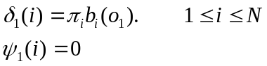
Recursion: 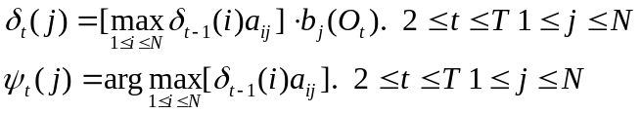 (A.6)
Termination: 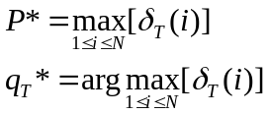
Backtracking: 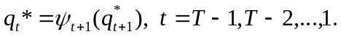

3 The Learning Problem: Expectation Maximization Algorithm

The last and the most difficult problem left is the estimation of the model parameters λ= (π, A, B), that is the priori probability and the transition and observation matrix. The well-known estimation algorithm, which is called Baum-Welch or Expectation Maximization (EM) algorithm, is based on forward-backward procedure illustrated in figure A.2. The key idea of the algorithm is to estimate the expected number of transitions from the state S_{i} to the state S_{j} and emissions of the symbol t in the state S_{i} based on the current parameter values and the training observation sequence. These estimates are then used to recalculate the parameters of the model. The process continues until the stopping criterion is reached.
1
2
N
1
2
N
1
2
N
1
2
N
a₁₂
a₂₂
a_{N2}
a₂₁
a₂₂
a_{2N}
O_{t-1}
O_{t}
O_{t+1}
O_{t+2}
α_{t} (2)
β_{t+1} (2)
a₂₂ e₂ (O_{t+1})

Figure A.2: The forward-backward procedure
The algorithm uses the probabilities of transitions and emissions to approximate the corresponding counters. We can define a variable:
That is, the probability of being in state i at time t, and state j at time t+1, given the model and the observation sequence. Here, α_{t}(i) and β_{t}(i) are defined in equation (A.1) and (A.3). The numerator is the joint probability of being in the state i at time t, in the state j at time t+1, and emitting the observations O. Dividing the product by the probability of the observation sequence O, we obtain the conditional probability of the transition from the state i to the state j at time t. Summing the estimates for transition counters over time, we obtain the expected number of transitions. To estimate the number of emissions, we use the sum of the posterior probabilities at time when the symbol was emitted. These estimates are used to recalculate the model parameters. The algorithm stops when the difference between two consecutive values of likelihood function is less than a threshold, or the maximal number of iterations is exceeded. The Baum-Welch algorithm is shown in the follows:
Initialization: Randomly choose model parameters. Set A_{ij} and B_{i}(t) to pseudo-count values.
Iteration:
• Calculate α_{i}(l) and β_{i}(l) for i=1,N and l=1, T. And
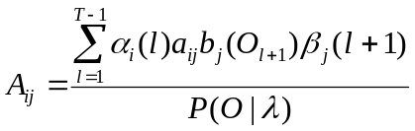 (A.7)
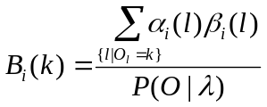
• Estimate new model parameters:
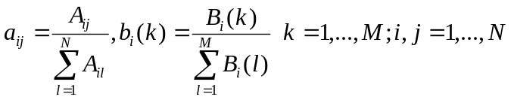 (A.8)
Termination: When the stop criterion is reached.
Please note that the equations perform both the expectation step and the maximization step simultaneously. The algorithm proceeds by using the newly derived parameters as the guess for the next iteration.

References
[1] D. A. Forsyth and J. Ponce, Computer Vision: A Modern Approach. Prentice Hall, 2003
[2] L. R. Rabiner and B. H. Juang, Fundamentals of Speech Recognition. Prentice-Hall, 1993
[3] L. R. Rabiner, A tutorial on hidden Markov models and selected applications in speech recognition. Proceedings of the IEEE 1989
[4] V. A. Petrushin. Hidden Markov Models: Fundamentals and Applications. Online Symposium for Electronics Engineer 2000
[5] S. Fine, Y, Singer and N. Tishby, The Hierarchical Hidden Markov Model: Analysis and Applications. Machine Learning, vol. 32, 41-62 1998
[6] M. Brand Coupled Hidden Markov Models for Modeling Interacting Processes. MIT Media Lab Perceptual Computing/Learning and Common Sense Technical Report 405 (Revised), June 1997.
[7] M. Brand, N. Oliver, and A. Pentland. Coupled hidden Markov models for complex action recognition. In IEEE International Conference on Computer Vision and Pattern Recognition, pages 994–999, 1997.
[8] S. Chu, T. Huang, “Audio-Visual Speech Modeling using Coupled Hidden Markov Models,” Proceedings of IEEE International Conference on Acoustics, Speech and Signal Processing, Orlando, 2002.
[9] A. Nefian, L. Laing, X. Pi, L. Xioxiang, C. Mao and K. Murphy, “A Coupled HMM for Audio Visual Speech Recognition,” Proceedings of IEEE International Conference on Acoustics, Speech and Signal Processing, Orlando, 2002.
[10] A. Subramanya, E. Patterson, S. Gurbuz, J. Gowdy, Audio-Visual Speech Integration using Coupled Hidden Markov Models for continuous Speech Recognition, IEEE International Conference on Acoustics, Speech and Signal Processing, Hong Kong, 2003.
[11] M. Jordan, Z. Ghahramani, L. Saul, Hidden Markov Decision Tree Neural information Processing Systems (NIPS) 1996
[12] L. Saul and M. Jordan, Boltzmann Chains and Hidden Markov Models Advances in Neural Information Processing Systems 1995
[13] H. McGurk and J. MacDonald. Hearing lips and seeing voices. Nature, pages 746–748, September 1976.
[14] Advanced Multimedia Processing Lab, CMU, http://amp.ece.cmu.edu/pro-jects/AudioVisualSpeechProcessing/.
[15] A. Nogueiras, A. Moreno, A. Bonafonte, J. B. Marino, Speech Emotion Recognition Using Hidden Markov Models, Proceedings of EUROSPEECH01, September, 2001.
[16] T. F. Cootes, G. J. Edwards and C. J. Taylor, Active Appearance Models. Proceedings of European Conference on Computer Vision, Vol. 2, pp. 484-498, Springer, 1998.
[17] Y. Rui, T. Huang, and S.-F. Chang, Image Retrieval: Past, Present, and Future in Proceedings of International Symposium on Multimedia Information Processing Taiwan, Dec. 1997
[18] P. Aigrain, H. Zhang, and D. Petkovic, Content-based Representation and Retrieval of Visual Media: A State-of-the-Art Review. In Multimedia tools and applications, volume 3, pages 179-202
[19] A. Krogh, M. Brown, I. S. Mian, K. Sjolander and D. Haussler. Hidden Markov models in computational biology: applications to protein modeling. Journal of Molecular Biology, pp 1501-1531 1994
[20] N. Dimitrova, H. Zhang, B. Shahraray, I. Sezan, T. Huang, A. Zakhor. Applications of Video-Content Analysis and Retrieval, IEEE Multimedia 7(3), 42-55, 2002
[21] Q. Huang, Z. Liu, A. Rosenberg, D. Bibbon, and B. Shahraray. Automated Generation of News Content Hierarchy by Integrating Audio, Video, and Text Information. Proc. IEEE Int’l Conf. Acoustics, Speech, and Signal Processing (ICASSP 99), IEEE CS Press, Los Alamitos, CA, 1999.
[22] H. Papageorgiou, A. Protopapas, and T. Netousek. Retrieving Video Segments Based on Combined Text, Speech and Image Processing. Proceedings of NAB Broadcast Engineering Conference pp. 177-182, 2003
[23] A. Ghoshal, P. Ircing, and S. Khudanpur, Hidden Markov Models for Image and Video Retrieval Using Textual Queries. In: Available at: http://www.clsp.jhu.edu/ws2004/groups/ws04vstxt/. (2004)
[24] L. A. Liporace, Maximum likelihood estimation for multivariate observations of Markov source. IEEE Transaction on Information Theory, vol. IT-28, no.5, pp. 729-734, 1982
[25] B. H. Juang, Maximum likelihood estimation for mixture multivariate stochastic observations of Markov chains, AT&T Tech. J., vol. 64, no. 6, pp. 1235-1249, July-Aug. 1985
[26] B. H. Juang, S. E. Levinson, and M.M. Dondhi, Maximum likelihood estimation for multivariate mixture observations of Markov chains, IEEE Transaction on Information Theory, vol. IT-32, no, 2, pp. 307-309, Mar, 1986
[27] A. V. Lukashin and M. Borodovsky. GeneMark.hmm: new solutions for gene finding. Nucleic Acids Research, vol. 26, No.4 pp 1107-1115, 1998
[28] M. Borodovsky and J. Mcininch. GenMark: parallel gene recognition for both DNA strands. Computers Chem. vol. 17, No.2, pp. 123-133, 1993
[29] A. Krogh, I. S. Mian and D. Haussler. A hidden Markov model that finds genes in E.coli DNA. Nucleic Acids Research, vol. 22, No.22 pp 4768-4778, 1994
[30] M. Chan, A. Hoogs, J. Schmiederer, M. Pertersen. Detecting Rare Events in Video Using Semantic Primitives with HMM. Proceedings of the 17th Int. Conf. on Pattern Recognition (ICPR'04) August 2004
[31] S. Hongeng and R. Nevatia, Large-Scale Event Detection Using Semi-Hidden Markov Models. Proceedings of Int. Conf. on Computer Vision, pp. 1455-1462,2003
[32] D. Zhang, D. G. Perez, S. Bengio and I. McCowan, Semi-Supervised Adapted HMMs for Unusual Event Detection. Proceedings of Int. Conf. on Computer Vision and Pattern Recognition (CVPR'05), June 2005
[33] Z. Ghahramani and M. Jordan, Factorial Hidden Markov Models, Machine Learning, vol. 29, 245-275 1997
[34] L. K. Saul and M. I. Jordan, Boltzmann Chains and Hidden Markov Models. In G. Tesauro, D. S. Touretzky, and T. K. Leen (Eds.), Advances in neural information processing systems 7. pp. 435-442Cambridge, MA: MIT Press 1995
[35] M. I. Jordan, Z. Ghahramani, and L. K. Saul, Hidden Markov decision tree. In M. Mozer, M. Jordan, and T. Petsche (Eds.), Advances in neural information processing systems 9. Cambridge, Ma: MIT Press 1997
[36] A. Jain, R. P. W. Duin and J. Mao, Statistical Pattern Recognition: A Review IEEE Transactions on Pattern Analysis and Machine Intelligence. vol. 22, No. 1, January 2000
[37] J A. Bilmes, A Gentle Tutorial of the EM Algorithm and its Application to Parameter Estimation for Gaussian Mixture and Hidden Markov Models, Technical Report U. C. Berkeley, April 1998
[38] Y. Bengio, Markovian Models for Sequential Data Neural Computing Surveys 2, pp, 129-162, 1999
[39] M. Song, J. Bu, C. Chen and N. Li, Audio-Visual based Emotion Recognition - A New Approach. Proceedings of Int. Conf. on Computer Vision and Pattern Recognition (CVPR'04), June 2004
[40] M. Pardas, A. Bonafonte, and J. Landabaso, Emotion Recognition Based on MPEG4 Facial Animation Parameters, Proceedings of IEEE ICASSP’2002, vol. 5, pp. 3624-3627, May, 2002.
[41] F. Dellaert, T. Polzin, and A. Waibel, Recognizing emotion in speech Proceedings of the ICSLP ’96, October, 1996.
[42] S. Bengio, An Asychronous Hidden Markov Model for Audio-Visual Speech Recognition, In S. Becker, S. Thrun, and K. Obermayer (Eds.) Advances in Neural Information Processing System, NIPS 15, pp.1237-1244, MIT Press, 2003.
[43] H. Zhong, J. Shi, and M. Visontai. Detecting unusual activity in video. Proceedings of Int. Conf. on Computer Vision and Pattern Recognition (CVPR'04), June. 2004.
[44] G. Medioni, I. Cohen, F. Bremond, S. Hongeng, and R. Nevatia. Event detection and analysis from video streams. In IEEE Transactions on Pattern Analysis and Machine Intelligence, vol. 23(8) August 2001.
[45] S. Gong and T. Xiang. Recognition of group activities using a dynamic probabilistic network. In Proc. IEEE ICCV, Nice, Oct. 2003.
[46] N. Johnson, D. Hogg, “Learning the Distribution of Object Trajectories for Event Recognition.” Image and Vision Computing, Vol. 14, pp. 609--615, 1996.
[47] D. Yuk and J. Flanagan, Telephone Speech Recognition using Neural Networks and Hidden Markov Models, In Proc. IEEE ICASSP vol.1 pp, 157 - 160 1999
[48] A. P. Varga and P, K. Moore, Hidden Markov Model Decomposition of Speech and Noise, In Proc. IEEE ICASSP vol.2 pp, 845 - 848 1990
[49] D. Yuk, C. Che, L. Jin and Q. Lin, Environment-Independent Continuous Speech Recognition using Neural Networks and Hidden Markov Models, In Proc. IEEE ICASSP vol.6 pp, 3358 - 3361 1996
[50] R. C. Rose and D. B. Paul, A Hidden Markov Model Based Keyword Recognition System, In Proc. IEEE ICASSP vol.1 pp, 129 - 132 1990
[51] L. E. Baum and T. Petrie, Statistical inference for probabilistic functions of finite state Markov chains, Ann. Math. Stat., Vol. 37, pp. 1554-1563, 1966
[52] L. E. Baum, T. Petrie, G. Soules, and N. Weiss, A maximization technique occurring in the statistical analysis of probabilistic functions of Markov chains, Ann. Math. Stat., vol. 41, no. 1, pp. 164-171, 1970
[53] L. E. Baum, An inequality and associated maximization technique in statistical estimation for probabilistic functions of a Markov process, Inequalities, vol. 3, pp. 1-8, 1972
[54] Olivier Cappé, Ten years of HMMs, http://www.tsi.enst.fr/~cappe/docs/hmmbib.html CNRS, LTCI & ENST, Department, TSI, March 2001
[55] D. R. H. Miller, T. Leek and R. M. Schwartz, A Hidden Markov Model Information Retrieval System, ACM SIGIR 1999
[56] Y. Bengio and P. Frasconi, An Input Output HMM architecture, In G. Tesauro, D.S. Touretzky, and T.K. Leen, editors, Advances in Neural Information Processing Systems 7, pages 427-434. MIT Press, Cambridge, MA.
[57] F. Jelinek, Statistical Methods for Speech Recognition. Cambridge, Massachussetts: MIT Press, 1998
[58] R. Cole, J. Mariani, H. Uszkoriet, A. Zaenen, and V. Zue, Survey of the State of the Art in Human Language Technology. http://www.cse.ogi.edu/CSLU/HLTsurvey/HLTsurvey.html Cambridge University Press, 1996

